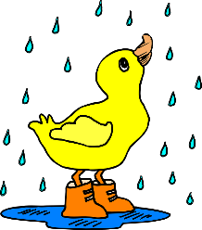
Around Our Town
Newdale Newsletter
Volume 5, Issue 1 April 2019
The City of Newdale will be holding its annual Easter Egg Hunt
on Saturday April 20, 2019, at 10 a.m. SHARP! Bring your own baskets. Times and places per age:
1-4 year olds by the Post Office
5-7 year olds by the City Building
8-11 year olds at the City Park
Find an egg with a number inside to claim a prize!!

Spring Clean-up
Spring Clean-Up will take place this year from now until June 1. Dumpsters will be provided on the city lot on main street from May 1st to June 15th. We would appreciate it if everyone would do their own cleaning and then deposit it in the dumpsters. This does not include household garbage. If you have an item that is too heavy for you to transport to the dumpsters, please let a city council member know and we will make arrangements to assist you.
A picnic and door prizes will be furnished by the city on June 1 at 1 pm.

In order to keep our city green and beautiful water will not be metered; however,
an additional $10 will be charged on your water bill – May through September.

It’s time to start planning for
“Newdale Fireworks 2019”
We are going to begin taking DONATIONS to make this as big – if not better than last year. We need at least $5,000 to reach our goal. Please help us out by sending money in a separate check. You can drop it off in the city drop box by the post office.We will track it and keep you up to speed with our progress.

