Around Our Town
Newdale Newsletter
Volume 3, Issue 2 June 2017
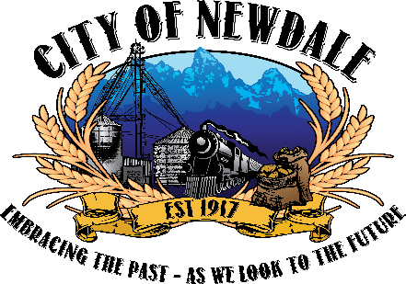
“JUNE IS BUSTING OUT ALL OVER” with Newdale’s Centennial Celebration. Come one, come all, on June 24th to the Newdale Park to celebrate 100 years of the beginning of our City. There will be dinner at 6 p.m., and a program following with fireworks when it gets dark. There will be bounce houses for the kids and lots of visiting and reminiscing with friends and guests.

EXCITING NEWS FOR WATER USERS: It has been approved by the City Council to increase the allowed water usage from 10,000 gallons to 50,000 gallons for the base rate during the months from June 1 to September 30. We hope everyone will take advantage without abusing this approach to keep our city green and beautiful.
PARKS
Heads UP!
We have experienced some vandalism at our park shelter and restrooms. Please be aware of this situation and counsel your family members.

It takes everyone’s help to keep the park a nice place for everyone to enjoy.

REMEMBER: NO animals and NO camping allowed in the park! This includes the park by the city building.

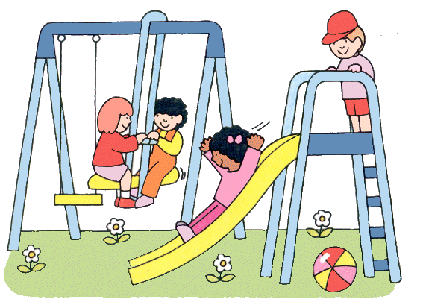
It would surprise you to know some of the items we have found in our sewer lift station, they include: hypodermic needles, adult diapers, feminine products, clothing and other things that we cannot identify. Please caution and inform your family members to keep our system clear and not incur expenses to clean them.
In addition, it is a federal offense to remove a manhole cover for any purpose whatsoever.

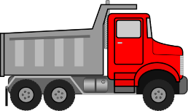
A BIG thank you goes out to all of those who helped with our city clean-up this past week. We hauled twelve truckloads of junk and debris to the dump. Everyone seems to have taken an interest in cleaning and maintaining their own property as well. It was greatly appreciated for the five young men who assisted the adults with picking up and loading the trucks. They were: Tucker Schwendiman, Hunter Schwendiman, Parker Harris, Carter Harris, Trey Wilson, Teghan Wilson, and adults: Scott Brewer with Taya and Kasidee, Tyler Grover with Addison, Jess Brown, Dal Schwendiman, Chad Stevens, John Briggs, Ferron Martineau. We appreciated the extra equipment from Harris Farms and Dal Schwendiman. The picnic was done by Erica Grover, Jerri Grover, and Ronda Leavitt. The raffle prizes were by Ann Schwendiman, Michelle Egbert, Jenn Wood, Nikki Andreasen, Carol Hymas, Savanah Duff, Falina Neiderer and Tessa Gomm. Thank you to Raymonda Furness for getting it all put together and Heidi Furness for pitching in on Saturday.

